3rd Sunday of Easter April 17, 2024

St. John Evangelical Lutheran Church
(The Lutheran Church-Missouri Synod)
4527 Second St. P.O. Box 206
Port Hope, MI 48468
stjohnsec@stjohnporthope.org www.stjohnporthope.org
Church Office: 989-428-4140 Pastor home/parsonage: 989-428-3305
Pastor: Rev. David A. Dodge Secretary: Sally Arndt

WELCOME! It’s our privilege to have you join us in being in the Presence of our Lord and Savior! At St. John, we follow the historic Liturgy of the Christian Church, which highlights the Biblical understanding of the True worship of God: first and foremost, that He Comes into our presence to give us His Saving Gifts (“Divine Service”) in His Word and Sacraments; and then, in response, we thank and praise Him in word and song, and pray for His continued Blessings.

Who should receive Holy Communion at St. John?: All Confirmed members are invited to Commune, who are sorry for their sins and wish to be Forgiven and Strengthened. Also, visitors from other L.C.-M.S. and T.A.A.L.C. churches, who fit the same description, are welcome. So that no one else might eat and drink in Judgment of their sins (1 Cor. 11:29), all others are asked to refrain from Communing. If you’re in doubt, please see Pastor or an Elder.

Prelude

Opening Hymn: “Hail, Thou Once Despised Jesus” ~ LSB #531

ORDER OF SERVICE: “Divine Service, Setting 1” ~ LSB pp.151ff.
Introit (see 1st white insert; read responsively by half Verse)
“Growing as One” (second white insert)
Readings (see first white insert)
Gradual (see front of same insert; read responsively by half Verse).
(The Gospel is read from the center of the Nave to represent Christ’s Risen Presence among us.)

Hymn of the Day: “With High Delight Let Us Unite” ~ LSB #483 (memory)

Sermon: “ ” Acts 3:11-21
Distribution Hymns:
“We Are Called to Stand Together” ~ LSB #828
“Children of the Heavenly Father” ~ LSB #725
“At the Lamb’s High Feast We Sing” ~ LSB #633

“Closing Hymn: “God’s Own Child, I Gladly Say It” ~ LSB #594

Postlude

STEWARDSHIP OF PARTICIPATION

DATE: SERVICE ATTENDANCE COMMUNION
4-7: 8:00 | 36 | 31
4-7: 10:00 | 41 | 33
4-7: Total | 77 | 64
4-7: SS / Bible Class | 0 / 3
4-10 Bible Study

STEWARDSHIP OF SERVICE
TODAY
Organist: Kristen Weiss
Ushers (8/10): Randy Smaglinski, Cody Siemen, Marv Koglin, Bryce Schave / Les Weiss, Steven Weiss Joe Weiss
Elder(s) (8/10): Dan Blacker / Don Clark
Acolyte (8/10): Jett Zimmerman / Brady Iseler
Altar Guild: Ann Reinke, Darla Pankow

NEXT SUNDAY
Organist: Kristen Weiss
Ushers (8/10): Randy Smaglinski, Cody Siemen, Marv Koglin, Bryce Schave / Les Weiss, Steven Weiss, Joe Weiss
Elder(s) (8/10): Greg Woodke / Harold Collings
Acolyte (8/10): Maddix Thoms / Sophia Koglin
Altar Guild: Ann Reinke, Darla Pankow

LOOKING AHEAD TO NEXT SUNDAY

READINGS HYMNS
Psalm: 4 531
1st: Acts 3:11-21 483
Epistle: 1John 3:1-7 828; 725; 633
Gospel: Luke 24:36-49 594

April Newsletters are in your mailboxes.

2024 Flower Chart is up on the window in the entryway, Please sign up on your special occasion dates to provide flowers to beautify our Chancel; or call Vicki Koglin at 989-225-7060.

April – June Portals of Prayer are available in the entryway basket.

2024 Offering Envelopes are available in the entryway.

A friendly reminder: Newsletter submissions are due to the church office by the 15th of the month preceding the month for publishing. Bulletin announcements are due to the church office by Thursday (9:00am) before the Sunday to be published, in writing.

The April Lutheran Witness (with Michigan in Touch) is available on the entryway table.

THIS WEEK at ST. JOHN

Sun: | 8:00 | Divine Service w/ Holy Communion, pp.151ff.
 | 9:00 | Sunday School / Bible Class
 | 10:00 | Divine Service w/ Holy Communion, pp.151ff.
Mon: | 6:00 | Finance Board
Tues: | 10:00 | “Winkel” @ Sebewaing
 | 7:30 | Long Range Planning
Wed: | 10:30 | Bible Study
Thurs: | 7:30 | Church Council
Next Sun: | 8:00 | Divine Service w/ Holy Communion, pp.151ff.
 | 9:00 | Sunday School / Bible Class
 | 10:00 | Divine Service w/ Holy Communion, pp.151ff.

OFFICE HOURS:
Monday: (Pastor & Sally): 9am – 1pm; 2-3pm
Tuesday: (Pastor): 9am – 12pm
Wednesday (Pastor & Sally): 9am – 12pm
Thursday: (Pastor): 9am – 12pm
Friday: (Pastor & Sally): 9am – 12pm
Please call ahead to ensure that someone is in at (989) 428-4140
2022 Debt Fund
January 1- December 31, 2024
Total Needed  Received (3-25-24)  Received year to date  Amount Still Needed | $ 27,000.00  $ 200.00  $ 1,000.00  $ 19,750,00

BUDGETED FINANCE REPORT - Not Including Special Accounts
January 1- December 31, 2024
Needed per count  Received (3-25-24)  Needed year to date  Received year to date | $ 7,550.00  $ 5,180.00  $ 46,920.00  $ 44,205.00

Bulletins provided by Ramsey Funeral Home, Harbor Beach, MI Phone 800-251-8695
PRAYER LISTS The following members and friends are known to be in the hospital, ailing or recovering and are in need of our prayers, cards, and visits.

MEMBER PRAYERS:
Rosemary Koglin; Logan Phillips; Lavern & Brenda Friedland; Lyle Schave;
Stephanie VerEllen

SHUT-INS:

Roger Friedland  (Huron Co Medical, B.A.) | Yvonne Fuhrman | Norma Johnson  (Lakeview E.C., H.B.)
Joyce Koglin  (Meadow Lane, B.A.) | Elmer/Ruth Leese | Jack Noble
Jeanette Piotter  (Lakeview E.C., H.B.) | Gary Schave  (Meadow Lane, B.A.) | Jeffrey Schave
Sandy Struble  (Meadow Lane, B.A.) | Jeannie Woodke  (Huron Co. Medical, B.A.)

FRIENDS:
Isabel Mix (great-granddaughter of Elmer & Ruth Leese)
Reecilyn Joy (daughter of Michael and Julie Joy)
Gordon Summers
Karen Kreh (daughter of Joyce Koglin)
Daryl Sengstock
Natalie Morgan (daughter of Shannon Popour’s co-worker)
David Sias (great-grandson of Elmer & Ruth Leese)
Debbie Pokora (sister-in-law of Mary Eggert)
Jaxon Bates (infant great-grandson of Elmer & Ruth Leese)
Ryder Finkel (grandson of Don & Linda Finkel)
Daniel Polega
Duane Schave
Chris Verellen (husband of Kari Verellen)
Leroy Pleiness
Julie Kreh (daughter of Joyce Koglin)
Quentin Musolff (grandson of Harlan & Ann Reinke)

Ladies Aid will be meeting on Monday, April 15th at 7:00pm. All ladies invited to attend.

The LWML District Convention will take place June 28-30. At last count, our Mission Goal for Grants was short $27,000. This is the last "push" for the Mite boxes for the last quarter before Convention takes place. Please see if you have some extra change stashed somewhere that you might be able to donate to this worthy endeavor. If not, please pray that LWML will reach their goal for grants. Thank you to all who have already contributed.
The Huron County Right to Life is sponsoring a local senior scholarship. Students need to submit a 400-500 word essay on the prompt: Reflect on areas where you believe your character has grown throughout your journey as a young pro-life advocate and how this influences your future goals. The local winner will receive $500 and advance to the state level round where one $500 scholarship will be awarded. Contestants must submit their application and essay to HURONRTL@gmail.com by 11:59pm on April 19, 2024. The application can be found at HURONRTL.org. Contact Jeanne Gusa at 989-670-3315 with any questions.

WHERE IN THE WORLD ARE YOU GOING? Orphan Grain Train—Michigan answers this time: Lima, Peru. A shipment will be departing this month for South America. We never know where the next destination might be in the world, but we do know where we have been in the past. Since 2019 the Michigan branch of Orphan Grain Train has made humanitarian shipments to Kyrgyzstan, Panama, Moldova, the Republic of Georgia, Latvia, Lithuania, Ukraine, Malawi, and South Sudan. Distributions are also always accompanied by the sharing of the Gospel of Christ. We thank those who participate and pray for this Christian mission. Learn more about Orphan Grain Train at ogt.org. Pictures from the Michigan branch may also be seen at ogt-mi.blogspot.com.

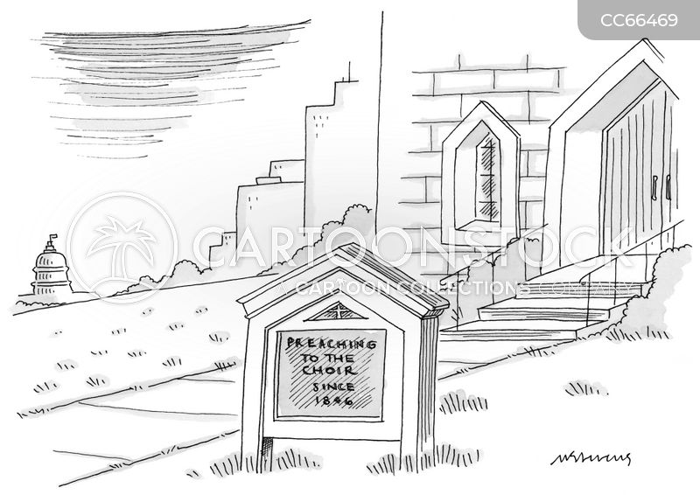
A Smile from Sally:

