FESTIVAL/COMMEMORATION DAYS IN FEBRUARY
Feb. 2 The Purification of Mary & the Presentation of Our Lord
Feb. 5 Jacob (Israel), Patriarch
Feb. 10 Silas, Fellow Worker of Sts. Peter & Paul
Feb. 13 Aquila, Priscilla, Apollos
Feb. 14 Valentine, Martyr
Feb. 15 Philemon & Onesimus
Feb. 16 Philipp Melanchthon (birth), Confessor
(author of the Augsburg Confession & its Apology)
Feb. 17 Ash Wednesday
Feb. 18 Martin Luther, Doctor & Confessor
Feb. 23 Polycarp of Smyrna, Pastor & Martyr
Feb. 24 St. Matthias, Apostle

“Growing as One”

The following memory items can be used within the daily office services in the Lutheran Service Book: Matins (pp.219ff.), Vespers (pp.229ff.), Morning Prayer (pp.235ff.), Evening Prayer (pp.243ff.), Compline (pp.253ff.), Responsive Prayers 1 (pp.282ff.) & 2 (pp.285ff.), and Daily Prayer for Individuals & Families (pp.294ff.).

Week Passage Catechism Hymn(s)*

Feb. 7 - 13 Luke 8:15 Keys - What? Where? Believe? LSB #824

Feb. 14 - 20 Luke 18:32-33 Lord’s Supper - What, Where? LSB #849

Feb. 21 - 27 Matt. 4:11 Lord’s Supper – Benefit? LSB #657

Feb. 28 – March 6 Matt. 15:28a-b Lord’s Supper - How? LSB #615

(*at least 1st stanza)

CHRISTIAN EDUCATION

Sunday School, 9:00 - 9:25am: miscellaneous material

Junior Confirmation classes:
6th-grade, Mondays, 4:00 - 5:30pm
7th-grade, Tuesdays, 4:00 - 5:30pm
Small Catechism, Workbook, videos, miscellaneous material
Wednesday Bible Study, 10:30 - 11:30am: Bible Difficulties and
Seeming Contradictions (1987, C.P.H.)
“Re-turn, Re-Lent”

Another “Ash Wednesday,” another season of Lent, another call by the Prophet Joel (2:13) to …
“… return to the LORD, your God, ...”
In fact, Joel says it twice; repeats it: “Return” and “return” (:12).
Is that a little redundant? After all, saying “re-” often already means to do something again, right?: “Re-start” means “start again;” “re-gain” means to “gain something again,” get something back that you had before; “re-seal” means “close” that package of bologna up “again;” “Re-turn”:
“Turn to the LORD, your God again, …”
and again.
It can’t be just on “Ash Wednesday” or just during the season of Lent that we confess our sins and “return to God,” can it! We sin every moment; it’s our very condition. Martin Luther said in the first of his “95 Theses” that the “entire life of believers” should be in penitence for our sins – “returning to God.” He said the significance of Baptism includes drowning the old sinful nature by contrition and penitence “daily”: “Turning to God, and re-turning,” again and again.
And what do we find?: That, Joel (2:14) also says, the LORD will “Relent” of punishing us as we deserve: “Re-lent.” Another “Ash Wednesday,” another Lent; another day of confessing our sins, always with the Assurance of God Forgiving those sins – again and again.

In His service & yours,
Pastor Dodge

NOTE: Anyone not attending public worship due to COVID-19 concerns and desiring Holy Communion can call the church office (989-428-4140) and request a visit from Pastor Dodge.

OFFICAL ACTS:
Deaths: Howard Finkel; 12-26-20

Transfers In: Gary & Michelle Schell, from Hope, Warren, MI; 1-19-21

Peaceful Release: Ashlyn Drews; 1-19-21

LUTHERAN WITNESS PODCAST

The Synod’s monthly magazine – Lutheran Witness – is now available in a listen-to podcast at the Synod’s radio station – KFUO. Please go to their website – www.kfuo.org – to access this service, as well as the station’s other features.
“ASK THE PASTOR”
Please note the “Ask the Pastor” box in the entryway. Questions submitted in the box (anonymously if you wish) may be used for this section of the newsletter.

Q: Why don’t we use the Apostles’ Creed and “This Is the Feast” as often anymore?

A: I believe I’ve addressed both of these questions previously, but they’re worth addressing again, as they’re asked from time-to-time.
The Nicene Creed is a more communal/corporate confession of faith, and therefore has traditionally been used for Communion Services. The Apostles’ Creed is a more Baptismal/personal confession of faith, and so is used traditionally in non-Communion services. You may remember that in the old The Lutheran Hymnal (1941) that the “Order of Morning Service” on “Page 5” (the non-Communion service) had only the Apostles’ Creed; and the “Order of the Holy Communion” on “Page 15” had only the Nicene Creed. Since at one time you only had Communion every-other Sunday, you would’ve used both equally often. Since we now (and for decades) have Holy Communion at every Sunday Service, we use the Nicene Creed most often. We do use the Apostles’ Creed in many of the mid-week Advent and Lenten services, which do not include the Sacrament.
The “This Is the Feast” option for the “Hymn of Praise” in Divine Service, Settings 1 and 2 (new with the Lutheran Worship hymnal [1982; which this congregation never got] & retained in our current Lutheran Service Book [2006]), is an Easter hymn (or other Festival Days). The more traditional “Gloria in Excelsis” (“Glory to God in the Highest”) is used more often for non-Feast days/seasons. I’ve chosen to use these Settings during the seven-week long Easter Season (using “This Is the Feast” every Sunday); and the second half of the long Pentecost/Trinity Season (roughly September through November; using “Glory to God in the Highest” those Sundays, except on Festival Days, when I’ll use “This Is the Feast”). I’m also using these Settings for the three “Pre-Lent” Sundays in the One-Year Series we’re now using (“Glory to God”) and for Pentecost and Trinity Sundays (“This Is the Feast”). Of course, during the Seasons that we use Settings 3 (the old TLH “Page 15;” Advent & Lent) and 4 (Epiphany & second half of Pentecost/Trinity), they have only the “Gloria in Excelsis” option. So, we probably use both of the “Hymn of Praise” options as often as you may have previously, but just for seasons when they’re individually more appropriate, rather than every-other-week just for the sake of variety.
Frankly, it’s also easier on the pastor and organist to stay with the same options for several Sundays in a row, rather than having to remember which option we’re using from week to week. Also, you’re encouraged to use the hymnal at home where you can choose for yourself which options, hymns, etc. to use.

YOUTH NEWS

The 2021 “Forgiven” Higher Things Lutheran Youth Conferences will be held: June 29 – July 2 at North Dakota State Univ., Fargo; July 6-9 at Colorado State Univ., Fort Collins; July 20-23 at Calvin University, Grand Rapids, MI; and July 27-30 at Concordia Univ.-Texas, Austin. Registration information has been mailed to all eligible youth (Confirmed through 12th-grade). THE “EARLY BIRD” REGISTRATION RATE HAS BEEN EXTENDED TO FEB. 28, 2021.

MID-WEEK LENTEN SCHEDULE

(Mid-week Wednesday services will take place at noon and 6:00pm here at St. John, and at 7:30pm at Zion, Harbor Beach. Due to COVID-19, there will be no pre-service soup suppers or imposition of ashes this year.)

“Four Significant Days”

Ash Wednesday, Feb. 17: “Significant Problem –
(with Communion; no ashes) Last Day in the Garden” Genesis 3:19

Wed., Feb. 24: “Significant Action –
(St. Matthias, Apostle) Monday of Holy Week” Mark 11:15-19

Wed., March 3: “Significant Questions –
Tuesday of Holy Week” Mark 12:28-37

Wed., March 10: “Significant Teaching –
Tuesday of Holy Week” Matthew 23:1-12

Wed., March 17: “Significant Final Appearance –
(Patrick, Missionary to Ireland) Tuesday of Holy Week” John 12:23-36

Wed., March 24: “Significant Deal –
Wednesday of Holy Week” Luke 22:1-6

FEBRUARY
ALTAR GUILD:
Vicki Koglin

CHURCH ATTENDANCE:
Average Church attendance for the month of December 2020: 116
Average Church attendance for the month of December 2021: 91

REPORT OF CONTRIBUTIONS
For the month of December 2020
Budget Income: General Fund: $22,429.37
Loose Offering: $1,421.77 TOTAL: $23,851.14

Non-Budget Income:
Trustees: $440.00 Missions: $585.00
Stained Glass: $ 865.00 Christmas Bulbs: $24.00
Special Stewardship: 80.00

Acolyte Schedule February, 2021
Feb. 7 | 8:00 | Jentry Zimmerman | 9:30 | Wyatt Hoody
Feb. 14 | 8:00 | Logan Iseler | 9:30 | Whitaker Bender
Feb. 17 Ash Wed. |  |  | 6:00 pm | Olivia Woodke
Feb. 21 | 8:00 | Wyatt Hoody | 9:30 | Whitaker Bender
Feb. 28 | 8:00 | Jentry Zimmerman | 9:30 | Logan Iseler

Acolyte numbers for Substitutions

Name | Phone | Name | Phone
Whitaker Bender | 989-975-9610 | Jordan Schave | 989-550-4609
Wyatt Hoody | 989-482-5071 | Olivia Woodke | 989-550-5931
Hunter Iseler | 810-300-7994 | Jentry Zimmerman | 989-551-7822
Logan Iseler | 810-300-7994



SERVICE WINTER WEATHER NOTICE:
In the case of severe Winter weather, a decision will be made as early as practically possible by Pastor and the head Elder on whether or not to officially cancel a worship Service. If a Service is to be cancelled, the decision will be disseminated on local media (WLEW AM/FM and website, and FM 103.7) and, if possible, added to the new church Facebook page. If, however, you don’t get the message of a cancellation, know that Pastor will be present to conduct some sort of service so that you didn’t venture out for nothing.

2021 OFFERING ENVELOPES are now available for pick up in the entryway. Please sign up on the numbered clip-board sheet on the bulletin table and take the corresponding numbered envelope box.

43rd Annual German Dinner, Sunday February 28, 11 am till 3pm. CARRY OUT ONLY. Zion Lutheran School, 299 Garden Street, Harbor Beach, pick up in the alley at the gym door. Enter alley from School Street and exit on Garden Street. If you live in town & want your meal delivered for free, call
989-479-3615, on Sunday 2/28 between 8am and 2pm. Sponsored by the Zion Lutheran PTL. Roast pork, sausage, sauerkraut, corn, mashed potatoes, applesauce, cranberry relish, roll & dessert for only $12.00 a meal.

February Wedding Anniversaries
Day |  | Yrs | 
5 | Frank & Irma Gaffke | 56
17 | Lavern & Brenda Friedland | 56
18 | David & Heather Bender | 15
 | Don & Kristi Pitts | 21
25 | Duane & Bonnie Koglin | 37

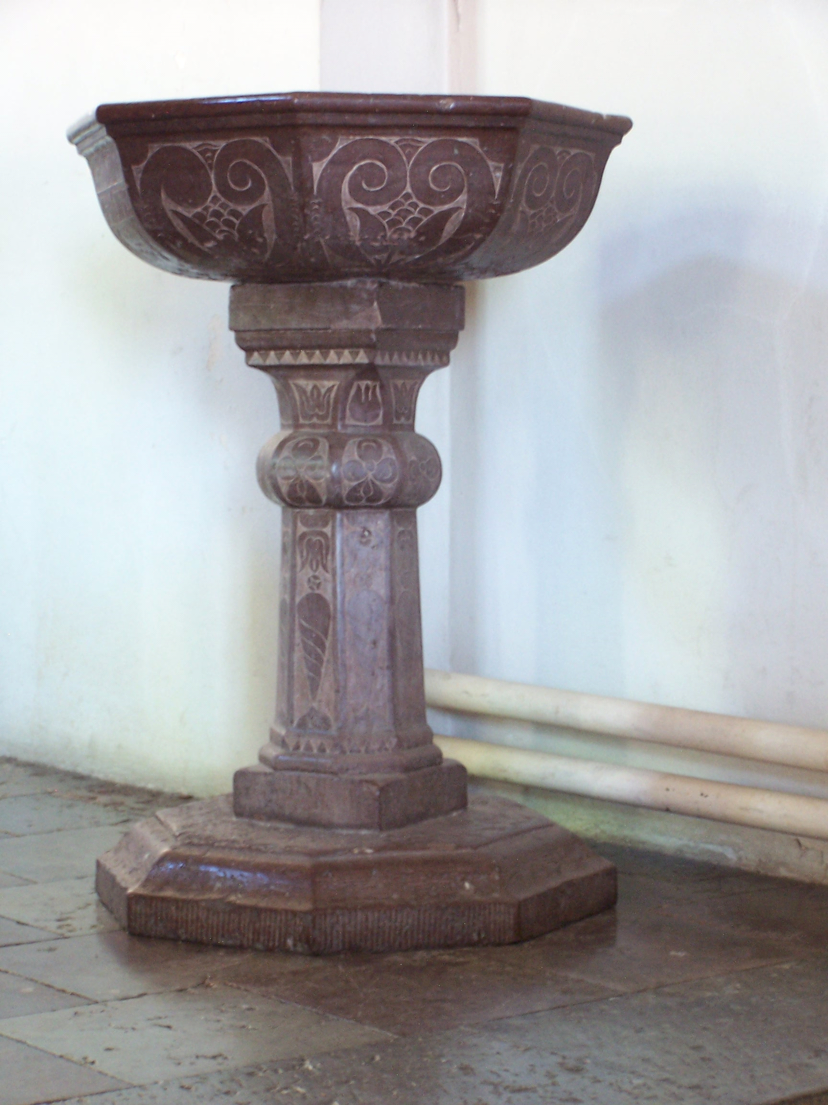

FEBRUARY BAPTISM BIRTHDAYS

1 | Meredith Birchfield | 2 | Brantley Brown | 4 | Amy Babcock
 |  |  |  |  | Allan Koglin
 |  |  |  |  | Eric Koglin
 |  |  |  |  | Matthew Koglin
5 | Darla Pankow | 6 | Jeffrey Schave | 7 | Kathie Reinke
10 | Deborah Bucholtz | 11 | Jesse Bender | 13 | Evan Dodge
 | Kathryn Rocha |  |  |  | Gavin Pawlowski
 |  |  |  |  | Michael Reinke
17 | Michael Lloyd | 19 | Shannon Stozeski | 21 | Joyce Friedland
 |  |  |  |  | James McNeil
22 | Gregory Brown | 23 | Heidi Nelson | 24 | David Berndt
 | Theodore Rink
28 | Elijah Ceplecha



FEBRUARY BIRTHDAYS
1 | Linda Iseler | 2 | Brian Bucholtz | 3 | Earl Reinke
 |  |  | Donald Finkel
 |  |  | Heidi Nelson
 |  |  | Tamara Talaski
4 | Misty Barrells | 5 | Brandon Bender | 7 | Evan Dodge
 | Arthur Haas |  | JoAnn Muter
 |  |  | Annabella Schubring
 |  |  | Matthew Terrasi
9 | Reena Hill | 10 | Cindy Chiotti | 11 | Jadyn Pitts
 |  |  | Shirley Rink |  | Terra Pleiness
13 | Joseph Weiss | 14 | Clinton Weiss | 16 | Casey Eggert
 | Arlene Zelz |  |  |  | Tammy Kessel
19 | Blake Bender | 20 | Charles Koglin | 21 | Amy Hunter-Cooper
 | Mary Michalski |  |  |  | Shirley Pawlitz
22 | Mason Soper | 25 | Gracie Prill | 26 | Mary Eggert
 |  |  | Isabella Prill |  | Emily Pleiness
 |  |  | Kenneth Reinke |  | Cathy Woodke
27 | Steven Schulz | 28 | Jason Bender
 |  |  | Arnold Kessel
 |  |  | Judy McTaggart
 |  |  | Angela Zinger

If there are any corrections or additions for the Birthday calendar.
Please call the Church Office 428-4140.

February 2021
SUNDAY SCHEDULE
8:00 Divine Service w/Communion
9:00 Sunday School
9:30 Divine Service w/Communion
Ushers 8:00 Ushers 9:30
Terry Emerick Albert Bender
Alan McTaggart Max Iseler
Don Finkel Scott Iseler
Sunday | Monday | Tuesday | Wednesday | Thursday | Friday | Saturday
 | 1  4:00 6th Confirmation Class | 2  4:00 7th Confirmation Class  Purification of Mary and Presentation of Our Lord | 3  10:30 Bible Study | 4 | 5 | 6  Pastor’s Day Off
7 | 8  4:00 6th Confirmation Class  7:00 Finance Board | 9  10:00 “Winkel” @ Cass City  4:00 7th Confirmation Class | 10  Pastor Vacation | 11 | 12 | 13  Pastor’s Day Off

14  Valentine, Martyr | 15  Presidents’ Day | 16  7:00 Trustees  7:00 Elders | 17Ash Wednesday  10:30 Bible Study  Noon Worship w/Communion; no ashes  6:00 Worship w/Communion & ashes | 18  Martin Luther, Dr. & Confessor | 19 | 20  Pastor’s Day Off
21 | 22  4:00 6th Confirmation Class  7:00 Finance Board | 23  4:00 7th Confirmation Class | 24  10:30 Bible Study  noon Lenten service  6:00 Lenten service  St. Matthias, Apostle | 25 | 26 | 27  Pastor’s Day Off
28 |  |  |  |  |  | Elders:  Gary Eggert 479-6251  Joe Landenberg 551-9899  Larry Reinke 551-4203  Greg Schave 428-3034  Les Weiss 551-4148  Greg Woodke 550-5931  Galen Young 550-3053

