The Resurrection of Our Lord – Easter April 4, 2021

St. John Evangelical Lutheran Church
(The Lutheran Church-Missouri Synod)
4527 Second St. P.O. Box 206
Port Hope, MI 48468
stjohnsec@stjohnporthope.org www.stjohnporthope.org
Church Office: 989-428-4140 Pastor home/parsonage: 989-428-3305
Pastor: Rev. David A. Dodge Secretary: Kathy Schave

WELCOME! It’s our privilege to have you join us in being in the Presence of our Lord and Savior! At St. John, we follow the historic Liturgy of the Christian Church, which highlights the Biblical understanding of the True worship of God: first and foremost, that He Comes into our presence to give us His Saving Gifts (“Divine Service”) in His Word and Sacraments; and then in response we thank and praise Him in word and song, and pray for His continued Blessings.

Who should receive Holy Communion at St. John?: All Confirmed members are invited to Commune, who are sorry for their sins and wish to be Forgiven and Strengthened. Also, visitors from other L.C.-M.S. and T.A.A.L.C. churches, who fit the same description, are welcome. So that no one else might eat and drink in Judgment of their sins (1 Cor. 11:29), all others are asked to refrain from Communing. If you are in doubt, please see Pastor or an Elder.

Prelude

Hymns: See worship folder.
ORDER OF SERVICE: “Divine Service, Setting 1” LSB pp.151ff.
Introit (see white insert; read responsively by half Verse)
“Growing as One” (see gold insert)
Readings (see back of white insert)
Gradual (see front of same insert; read responsively by half Verse).

Sermon: “He is Risen, indeed. You are Risen, indeed.” Isaiah 25:6-9
Postlude

---------------------------------------

2021 Flower Chart is up on the wall in the entryway. Please sign up on your special occasion dates to provide flowers to beautify our Chancel. Or call Vicki Koglin 989-225-7060.

Barnabas Fund: This fund is for the purpose of providing financial help for those in emergency need. Please consider donating toward this endeavor.
2021 OFFERING ENVELOPES are now available for pick up in the entryway. Please sign up on the numbered clip-board sheet on the bulletin table and take the corresponding numbered envelope box.

STEWARDSHIP OF PARTICIPATION
DATE: SERVICE ATTENDANCE COMMUNION
3-28-21: 8:00 | 61 | 54
3-28-21: 9:30 | 29 | 27
3-28-21: Total | 90 | 82
3-31-21: Bible Study | 7

STEWARDSHIP OF SERVICE
TODAY
Organist: Kristen Weiss
Ushers (6/8:00): Marv Koglin, Bryce Schave / Les Weiss, Steven Weiss, Joe Weiss
Elder(s) (6/8:00) Greg Schave / Gary Eggert
Acolyte (6/8:00): Olivia Woodke / Jordan Schave
Altar Guild: Ann Reinke, Darla Pankow

NEXT SUNDAY
Organist: Kristen Weiss
Ushers (8/9:30): Marv Koglin, Bryce Schave / Les Weiss, Steven Weiss, Joe Weiss
Elder(s) (8/9:30) Galen Young/ Les Weiss
Acolyte (8/9:30): Jentry Zimmerman / Logan Isler
Altar Guild: Ann Reinke, Darla Pankow

LOOKING AHEAD TO NEXT SUNDAY
READINGS HYMNS
Psalm: 33 490
O.T.: Ezekiel 37:1-14 470
Epistle: John 5:4-10 700
Gospel: John 20:19-31 482

April - June Portals of Prayer are available in the entryway.

The April Lutheran Witness (with Michigan In Touch) are available on the entryway table.

April newsletters are in your church boxes.
A friendly reminder…newsletter submissions are due to the church office by the 15th of the month preceding the month to publish. Bulletin announcements are due to the church office by Wednesday (9:00 am) before the Sunday to be published in writing.

THIS WEEK at ST. JOHN

Easter Sunday: | 6:00 | Sunrise Divine Service with Holy Communion Page 151
 | 8:00 | Divine Service with Holy Communion Page 151
Mon: | 4:00 | 6th Confirmation Class
Wed: | 10:30 | Bible Study
Thurs: | 7:30 | Church Council
Fri: | 5:30 | 7th Confirmation Class
Next Sun: | 8:00 | Divine Service with Holy Communion Page 151
 | 9:00 | Sunday School
Office Hours:
Monday: (Pastor) 9am – 11:30am; 1-2pm
Tuesday: (Pastor & Kathy): 9am – 11:30am; 1-2pm
Wednesday: (Pastor): 9am – 11:30am
Thursday: (Pastor & Kathy): 9am – 11:30am; 1-2pm
Friday: (Pastor & Kathy): 9am – 11:30am; 1-2pm
Please call ahead to ensure that someone is in at 989-428-4140.
Stained Glass Window Fund
Total Needed: $124,000.00
Received so far $ 97,900.00 Finance Board (3-22-21) $760.00
Amount Still Needed: $ 26,010.00

BUDGETED FINANCE REPORT - Not Including Special Accounts
January - December 31, 2021
Needed per count  Received (3-22-21)  Needed year to date  Received year to date | $ 8,150.00  $ 4,345.00  $48,900.00  $42,470.00

20 .

Bulletins provided by Ramsey Funeral Home, Harbor Beach, MI Phone 800-251-8699
____________________________________________________________________
Sunrise: Christ’s Resurrection Brings Us Life
“In Adam all die.” For we are all participants in the sin of Adam, who rebelled against God in the Garden and brought the curse of death into the world. But “in Christ shall all be made Alive” (1 Cor. 15:22). For He was Faithful to His Father and Destroyed death on the Holy Tree. Jesus, the “Second Adam,” now “walks in the Garden in the cool of the day” and Reveals Himself to the daughter of Eve (John 20:1–18). The Risen Christ brings not the curse of death but the Blessing of Life, the Resurrection of the body. He Leads us through the Baptismal Sea to New Life on the Other Side, Conquering our mortal enemies in its depths (Ex. 14:10—15:1). In this Way our Lord Jesus “Wipes away the tears from all faces.” For He has Swallowed up death forever. “Let us therefore be glad and rejoice in His Salvation” (Is. 25:6–9)!

Easter Flowers:
Lilies in Memory:
Grandson: Matthew Richardson; and Son-in-law: John Richardson; from Joyce Koglin

My husband: Marvin Koglin; from Joyce Koglin

Parents: Mr. & Mrs. Gust Koglin, and Mr. & Mrs. Otto Brade; from Joyce Koglin

Robert & Hilda Seidler, and Walt & Kate Bender; from Albert & Janice Bender

Gary Bismack from; Mary Eggert

Earl & Genevieve Collings, Melvin Collings, Brianna Collings, Arlene Collings, and Tina Pruitt; from Harold & Carolyn Collings

Edwin & Bernice Koglin, Chandra Koglin, Joyce M. Koglin, Robert & Ethel Gee, and Edward Gee; from Harold & Carolyn Collings

Son, Randall Reinke; from Larry & Kathie Reinke

Lucille Setter, and William Setter; from Shawn & Carol Young

Edwin and Florence Young: from Shawn & Carol Young

Lilies in Honor of:
Don & Kristi Pitts, and Jason & Staci Zimmerman; from Karen Iseler

Mom, Sharon Furhrman;from Corrinne Abraham

Tulips in Memory:
Agnes & Jacob Bismack; from Mary Eggert

Cindy Bender; from Albert & Janice Bender

Our daughter: Amy Deer; from Mom & Dad Harlan & Ann Reinke

Alvin & Sharon Finkel; from Garth & Shannon Popour

Aunt Diane Finkel; from Teresa Muter

My Dad, Alexander Weber; from Teresa Muter

Fred Muter; from Teresa Muter

Our parents: Casimir & Dolores Klesczewsk,i and Edward & Dorothy Pawlitz; from Norm & Shirley Pawlitz

Tulips Celebrating:
The Abraham Families; from Corinne Abraham

Hyacinths in Memory:
Clarence and Tina Bertschinger; from Lyle and Kathy Schave

Stephanie Wade; from Albert & Janice Bender

Joyce Muntz, & Beatrice Kerr; from Harold & Carolyn Collings

Larkin & Cathy Ervin; from Harold & Carolyn Collings

Bernard & Dorothy Pokora and Carol Pokora; from Mary Eggert

Ponch Pankow, Art & Lena Sengstock, and Milt & Ann Pandow; from Darla Pankow

Hyacinths Celebrating:
Our Grandchildren: Ronan, Miles and Crew Staat; from Norm & Shirley Pawlitz

Hyacinths in Honor of:
In Honor of our grandchildren: Paige, Ty, Olivia, Ethan, Luke, Shea, Mitchell, Calvin, Hazel, Avery, and Henry; from Marvin & Carol Woodke

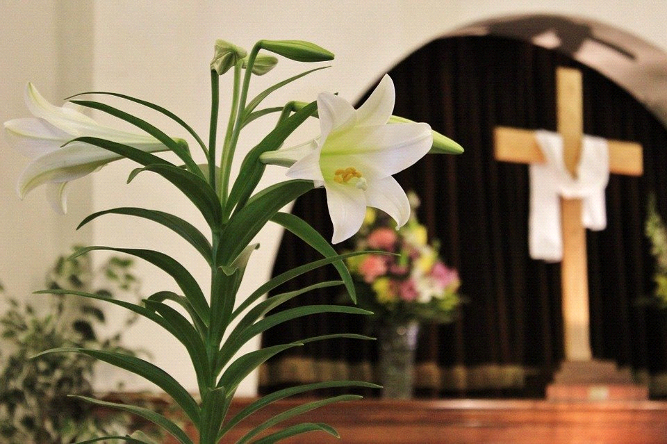

PRAYER LISTS The following members and friends are known to be in the
hospital, ailing or recovering and are in need of our prayers, cards, and visits.

MEMBER PRAYERS
The Family of Nelson Erbisch; Those with COVID-19

SHUT-INS
Ivan/Betty Adkins | Yvonne Fuhrman | Jeffrey Schave
Arnold Brown | Hugh Harwood  (Courtney Manor) | Wally Schave
Elaine Eggert  (Lakeview E.C.) | Charlie Koglin  (Courtney Manor) | Arlene Zelz  (Lakeview E.C.)
Della Finkel  (Courtney Manor) | Elmer/Ruth Leese
 | Willard/Ramona Reinke

FRIENDS
Brendan Durkee (grandson of Merle & Patsy Eggert)
Riley Durkee (granddaughter of Merle & Patsy Eggert)
Isabel Mix (great-granddaughter of Elmer & Ruth Leese)
Reecilyn Joy (daughter of Michael and Julie Joy)
Gordon Summers
Kathi Jahn (sister of Vicki Koglin)
Emmitt Gaffke (Frank & Irma Gaffke’s infant grandson)
Deborah Schubring (Ann’s daughter-in-law) (recovering from brain aneurism surgery)
Kenny Shepard (grandson of Joyce Koglin)
Family of Walt Strucinski (Joyce Koglin’s brother-in-law)
All those affected by COVID-19.

In Memory of Dave Schave, a monetary gift has been given to St. John Lutheran: Karen Karg
April 10th, Saturday, 4 to 6, Fish Fry at Zion Lutheran, Harbor Beach, Curb Side Pick-Up Only. Lightly battered pollock, scalloped potatoes, corn, spaghetti salad, coleslaw, roll and dessert. All Dinners $10.00. Take out only. Pick up in your car in the alley at the gym door. Enter on Garden Street.
TWO YEAR ORPHAN GRAIN TRAIN–MICHIGAN MILESTONE
Joy flourishes among volunteers at Michigan’s branch of Orphan Grain Train. With you we celebrate Christ’s resurrection victory and pray for you a blessed Easter. It is Jesus who also has given vitality to this Christian humanitarian mission. This Easter week marks the two-year anniversary of continuous operations at Orphan Grain Train–Michigan. We thank and praise God for enlivening your partnership in making international shipments to Kyrgyzstan, Panama, and with another fully ready this spring to people in need of a word well spoken, a bandage well applied, and a child well fed. Each shipment of aid and relief is accompanied with the message of Jesus’ resurrection and life.

