The Resurrection of Our Lord - Easter April 12, 2020
St. John Evangelical Lutheran Church
(The Lutheran Church-Missouri Synod)
4527 Second St. P.O. Box 206
Port Hope, MI 48468-0206
989-428-4140 stjohnsec@stjohnporthope.org www.stjohnporthope.org
Pastor: Rev. David A. Dodge Secretary: Kathy Schave

WELCOME! It’s our privilege to have you join us in being in the Presence of our Lord and Savior! At St. John, we follow the historic Liturgy of the Christian Church, which highlights the Biblical understanding of the True worship of God: first and foremost, that He Comes into our presence to give us His Saving Gifts (“Divine Service”) in His Word and Sacraments; and then in response we thank and praise Him in word and song, and pray for His continued Blessings.

Who should receive Holy Communion at St. John?: All Confirmed members are invited to Commune, who are sorry for their sins and wish to be Forgiven and Strengthened. Also, visitors from other L.C.-M.S. and T.A.A.L.C. churches, who fit the same description, are welcome. So that no one else might eat and drink in Judgment of their sins (1 Cor. 11:29), all others are asked to refrain from Communing. If you are in doubt, please see Pastor or an Elder.

Sunrise Hymn: LSB #459 (Pastor) ~ “Christ Is Arisen”
Processional Hymn: LSB #457 ~ “Jesus Christ Is Risen Today”
ORDER OF SERVICE: “Divine Service, Setting 1” LSB pp.151ff.
Introit (see yellow & white inserts; read responsively by half Verse)
Hymn: LSB #461 ~ “I Know That My Redeemer Lives”
“Growing as One” (see gold insert)
Readings (see back of yellow & white insert)
Gradual (see front of same inserts; read responsively by half Verse)
Hymn (Day): LSB #469 ~ “Christ the Lord Is Risen Today”
Gospel Hymn (Day): LSB #477 ~ “Alleluia, Alleluia! Hearts to Heaven”

Hymns of the Day (memory): Sunrise: LSB #467 ~ “Awake, My Heart, with Gladness”
Day: LSB #458 ~ “Jesus Lay in Death’s Strong Bands”
Sermons: Sunrise: “LIVING AMONG THE BIBLE’S TREES: Tree of Life””
Ps.52; Ezek. 47:1-12; Rev.22:1-20; Matt.28:1-10
Day: “Larger Than the Stone” Mark 16:1–8
Hymn: LSB #473 ~ “Our Paschal Lamb, That Sets Us Free”

Post-Creed Hymns: Sunrise: LSB #488 ~ “He’s Arisen! Glorious Word”
Day: LSB #478 ~ “The Day of Resurrection”

Offering Hymns: Sunrise: LSB #480 ~ “He’s Risen, He’s Risen”
Day: LSB #466 ~ “Christ Has Arisen, Alleluia”

Post Lord’s Prayer Hymns: Sunrise: LSB #463 ~ “Christ the Lord Is Risen Today, Alleluia”
Day: LSB #477 ~ “Alleluia! Jesus is Risen”

Recessional Hymn: LSB #465 ~ “Now All the Vault of Heaven Resounds”

STEWARDSHIP OF PARTICIPATION

STEWARDSHIP OF SERVICE
TODAY

NEXT SUNDAY

LOOKING AHEAD TO NEXT SUNDAY
READINGS HYMNS
Psalm: 33 909
469
O.T.: Ezekiel 37:1-14 470
482
Epistle: 1 John 5:4-10 472; 474; 597
Gospel: John 20:19-31 917

April – June Portals of Prayer are available in a box by the school doors.

The April Lutheran Witness (with Michigan In Touch) is available on the entryway table.
The April newsletters have been mailed.
A friendly reminder…newsletter submissions are due to the church office by the 15th of the month preceding the month to publish. Bulletin announcements are due to the church office by Wednesday (9:00 am) before the Sunday to be published.

THIS WEEK at ST. JOHN

Office Hours:
THE OFFICE IS CLOSED DIRING THE COVID-19 SHUT DOWN.
Stained Glass Window Fund
Total Needed: $124,000.00
Received so far $ 81,355.00 Finance Board (3-23-20) $ 130.00
Amount Still Needed: $ 42,645.00

BUDGETED FINANCE REPORT - Not Including Special Accounts
2019-2020 Fiscal Year
Needed per count  Received (3-23-20)  Needed year to date  Received year to date | $ 8,060.00  $ 5,705.00  $144,660.00  $129,220.00

20 .

Bulletins provided by Ramsey Funeral Home, Harbor Beach, MI Phone 800-251-8699
____________________________________________________________________
Sunrise: Christ’s Resurrection Brings Us Life
“In Adam all die.” For we are all participants in the sin of Adam, who rebelled against God in the Garden and brought the curse of death into the world. But “in Christ shall all be made Alive” (1 Cor. 15:22). For He was Faithful to His Father and Destroyed death on the Holy Tree. Jesus, the “Second Adam”, now “walks in the Garden in the cool of the day” and Reveals Himself to the daughter of Eve (John 20:1–18). The Risen Christ brings not the curse of death but the Blessing of Life, the Resurrection of the body. He Leads us through the Baptismal Sea to New Life on the Other Side, Conquering our mortal enemies in its depths (Ex. 14:10—15:1). In this Way our Lord Jesus “Wipes away the tears from all faces.” For He has Swallowed up death forever. “Let us therefore be glad and rejoice in His salvation (Is. 25:6–9)!”

Day: Christ’s Resurrection Means That We Will One Day Be Raised
“Christ, our Passover lamb, has been Sacrificed” (1 Cor. 5:7). By the shed Blood of Christ, the Lamb of God, eternal death has passed over us. Now we Pass with Christ through death into Life everlasting. For Christ the crucified One is Risen! The stone has been rolled away from the tomb, revealing that the tomb could not hold Him (Mark 16:1–8). Now our Redeemer Lives eternally to Save us from sin and Satan and the grave, and we can live in the sure Hope of our own bodily Resurrection with Christ. “After my skin has been thus destroyed, yet in my flesh I shall see God” (Job 19:26). Feasting on the Living Christ, who is our Meat and Drink indeed, we boldly say: “O death, where is your victory? O death, where is your sting? . . . But thanks be to God, who gives us the Victory through our Lord Jesus Christ”
(1 Cor. 15:54–55,57).

Easter Flowers:

Lilies in Memory:
My parents: Rev. E.J. Sander and Edna (Sander) Buetow from; Karen Iseler

Grandson: Matthew Richardson, and Son-in-law: John Richardson; from Joyce Koglin

My husband: Marvin Koglin; from Joyce Koglin

Parents: Mr. & Mrs. Gust Koglin and Mr. & Mrs. Otto Brade; from Joyce Koglin

My sister: Tina Bertschinger; from Kathy and Lyle Schave

Andrea Lou Piotter; from Rick Piotter & Family

Mr. & Mrs. Lee E. Brown; from Their Family

Robert & Hilda Seidler and Walt & Kate Bender; from Albert & Janice Bender

Mr. & Mrs. Walter Rink, Mr. & Mrs. William Fuhrman, and Gerald Fuhrman from; Yvonne Fuhrman

Gary Bismack from; Mary Eggert

Earl & Genevieve Collings, Melvin Collings, Brianna Collings, and Arlene Collings; from Harold & Carolyn Collings

Edwin & Bernice Koglin, Chandra Koglin, Robert & Ethel Gee, and Edward Gee; from Harold & Carolyn Collings

Tulips in Memory:
Agnes & Jacob Bismack; from Mary Eggert

Cindy Bender; from Albert & Janice Bender

My Mom & Dad: Shirley & Robert Witherspoon; from Sue Witherspoon

Our daughter: Amy; from Mom & Dad

My husband: Barney Schubring; from Ann Schubring

My husband: Ponch Pankow; from Darla Pankow

My parents: Art & Leona Sengstock; from Darla Pankow

Hyacinths in Memory:
Our parents: Casimir & Dolores Klesczewski and Edward & Dorothy Pawlitz; from Norm & Shirley Pawlitz

Stephanie Wade; from Albert & Janice Bender

Joyce Muntz & Beatrice Kerr; from Harold & Carolyn Collings

Larkin & Cathy Irvin; from Harold & Carolyn Collings

Bernard & Dorothy Pokora and Carol Jean Pokora; from Mary Eggert

Emil & Bessie Bucholtz, Elmer & Edna Koth, Ryan Koth, Everette & Ann Koth, Gary Bucholtz; from Elwin & Mary Koth

Tulips Celebrating:
Our Grandchildren: Ronan James, Miles Norman, and Crew William Staat; from Norm & Shirley Pawlitz

Hyacinths:
In Honor of our grandchildren: Paige, Ty, Olivia, Ethan, Luke, Shea, Mitchell, Calvin, Hazel, Avery, and Henry; from Marvin & Carol Woodke

In Honor of our daughter and her family: Scott, Martha, Weston & Gretchen Koglin; from Fred & Eugenia Roemer

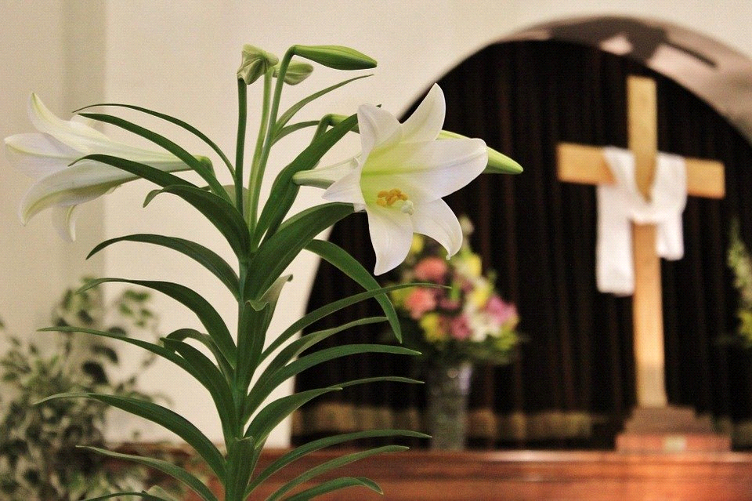

PRAYER LISTS The following members and friends are known to be in the
hospital, ailing or recovering and are in need of our prayers, cards, and visits.

MEMBER PRAYERS

SHUT-INS
Ivan/Betty Adkins | Mary Forbing | Willard Reinke
Arnold Brown | Yvonne Fuhrman | Jeffrey Schave
Wade Cohoon (Colorado) | Patricia Griffore | Gloria Schmalz
Elaine Eggert | Nathan Kaufman | Helen Schultz
Nelson Erbisch | Charlie Koglin | Arlene Zelz
Howard/Della Finkel | Elmer/Ruth Leese

FRIENDS
Lucille Setter (Mother of Carol Young)
Roman Jock (toddler cousin of Harold Collings)
Brendan Durkee (16 yr. old grandson of Merle & Patsy Eggert)
Riley Durkee (8 yr. old granddaughter of Merle & Patsy Eggert)
Ruby Maschke (Meadow Lane Assisted Living)
Isabel Mix (toddler old great-granddaughter of Elmer & Ruth Leese)
Jean Eggert (sister-in-law of Gary and Elain Eggert)
Earl Iseler
Staff Sergeant Ricky Holtz (recently deployed to South America; grandson-in-law of Emerson & Irene Pilaske), wife Kayla, and two sons.
Reecilyn Joy (daughter of Michael and Julie Joy)
All those affected by COVID-19.

Barnabas Fund: This fund is for the purpose of providing financial help for those in emergency need. Please consider donating toward this endeavor

2020 OFFERING ENVELOPES are now available for pick up in the entryway. Please sign up on the numbered clip-board sheet on the bulletin table and take the corresponding numbered envelope box.

2020 Flower Chart is up on the wall in the entryway. Please sign up on your special occasion dates to provide flowers to beautify our Chancel.
All you Can Eat Fish Fry at Zion Lutheran, Saturday May 9th. 3:30 to 6:30. Adults $10 and Kids (5-12) $5. Pollack, French fries, baked potato, corn, salads, desserts, coffee and water.

